ROAD ACCIDENT ANALYSIS
Transforming Road Safety Data into Actionable Insight Using Power BI

Sayan Sau
Anudip Foundation
CoE Kolkata
Senior Technical Trainer

Why I Selected This Project
Road safety is one of the most pressing public-health and infrastructure issues faced by any country, and the volume of accident-related data collected each year creates a genuine opportunity to apply business intelligence techniques to a problem that affects real lives. I chose the Road Accident Analysis project because it allowed me to move beyond a simple spreadsheet of numbers and instead build a dynamic, interactive dashboard that tells a clear story about when, where, and why accidents happen.
This project gave me the chance to apply the full Power BI workflow that I learned during the course: importing raw accident records, shaping and modelling the data, writing DAX measures for KPIs and year-over-year comparisons, and finally designing visuals that make a complex dataset understandable to a non-technical audience. Working with casualty severity, road type, lighting conditions, and urban versus rural classifications also helped me practise translating categorical and time-based data into insights that stakeholders could actually act on.
More broadly, the project reflects how data-driven decision-making can support policy and infrastructure planning. By quantifying where risk is concentrated — such as single carriageways, daylight hours, and urban centres — the dashboard demonstrates how analytics can directly inform safety interventions rather than simply describing historical events.

Keywords
Power BI | Data Analytics | Data Visualisation | DAX | Road Safety | Accident Severity | KPI Tracking | Year-over-Year Analysis | Dashboard Design | Public Sector Analytics

Target Audience
The findings of this project are intended for the following audiences:
- Transport Authorities and Policy Makers – To identify high-risk road types, locations, and time periods that warrant targeted safety interventions.
- Urban Planners and Infrastructure Engineers – To understand how road design (single carriageways, roundabouts, dual carriageways) correlates with casualty rates.
- Road Safety Campaign Teams – To design awareness initiatives around the riskiest conditions, such as daylight hours and urban traffic density.
- Data and Business Analysts – To see a practical example of KPI design, DAX measures, and dashboard storytelling applied to a real-world dataset.
- Students and Academic Evaluators – As a demonstration of applying Power BI's data modelling and visualisation capabilities to a complete analytics project.

Primary Target Audience
The primary target audience is transport and road-safety policy makers, who require clear, data-backed evidence to prioritise infrastructure improvements, enforcement measures, and public awareness campaigns aimed at reducing casualties.

Requirement Gathering
Before building any visuals, the key reporting requirements were defined so that the dashboard would answer specific business questions rather than simply display data:
- Primary KPI 1: Total Casualties and Total Accidents for 2022, with year-over-year growth.
- Primary KPI 2: Total Casualties by Accident Severity for 2022, with year-over-year growth.
- Secondary KPI: Total Casualties broken down by Vehicle Type for 2022.
- A monthly trend comparing casualties across 2021 and 2022.
- Casualties broken down by Road Type for 2022.
- Casualties in 2022 segmented by Area (Urban/Rural) and Light Condition (Day/Night).
- Total Casualties and Total Accidents mapped by Location.

Data Preparation and Modelling
The raw accident dataset was first reviewed for consistency before being loaded into Power BI:
- Reviewed the dataset for duplicate accident records and removed them to avoid double-counting casualties.
- Checked key columns — Severity, Road_Type, Light_Conditions, Urban_or_Rural_Area, and Number_of_Casualties — for blank or inconsistent values.
- Built a dedicated Date table and connected it to the accident records to enable time-intelligence calculations such as Year-to-Date and Year-over-Year comparisons.
- Validated relationships between the Date table and the main accident table through Power BI's Modelling view before building any visuals.

Power BI Dashboard Development
With the data modelled, the dashboard was assembled page by page, with each visual chosen deliberately to answer one of the requirement-gathering questions above.

Step-by-Step Build Process
- Opened Power BI Desktop and connected to the cleaned accident dataset using Get Data.
- Created a Calendar/Date table and linked it to the main Data table through Manage Relationships.
- Built KPI cards for Total Casualties, Total Accidents, and the severity breakdown (Fatal, Serious, Slight) using DAX measures.
- Added a line/area chart plotting the monthly casualty trend for 2021 versus 2022.
- Built a horizontal bar chart ranking casualties by Road Type.
- Added donut charts for Urban vs Rural share and for Light Conditions (Day vs Night).
- Added a map visual plotting casualties and accidents by geographic location.
- Applied slicers for Road Surface and Weather Conditions so users can filter the entire page interactively.

Key DAX Measures
Total Casualties = SUM(Data[Number_of_Casualties])
CY Casualties = TOTALYTD([Total Casualties], 'Date'[Date])
YoY Change = DIVIDE([CY Casualties] - [PY Casualties], [PY Casualties])
Serious Casualties = CALCULATE([Total Casualties], Data[Severity] = "Serious")
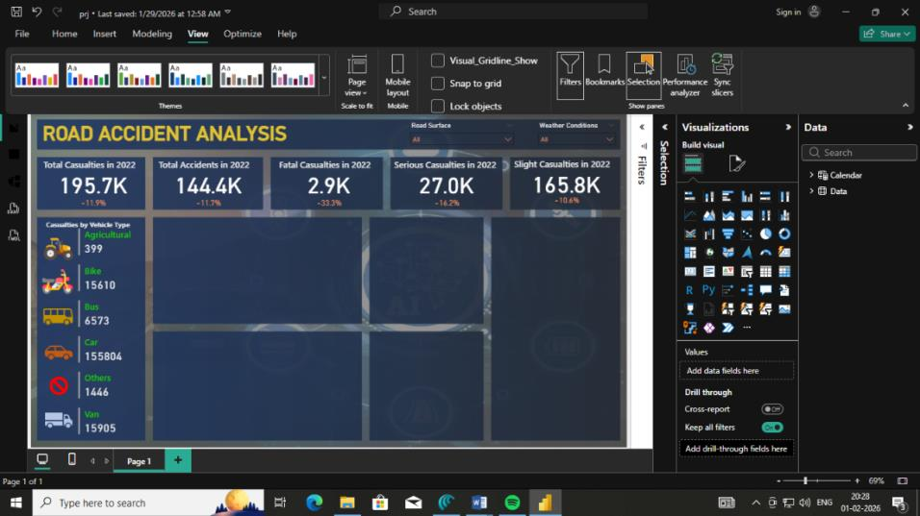
KPI summary cards showing total casualties, accidents, and severity breakdown for 2022.
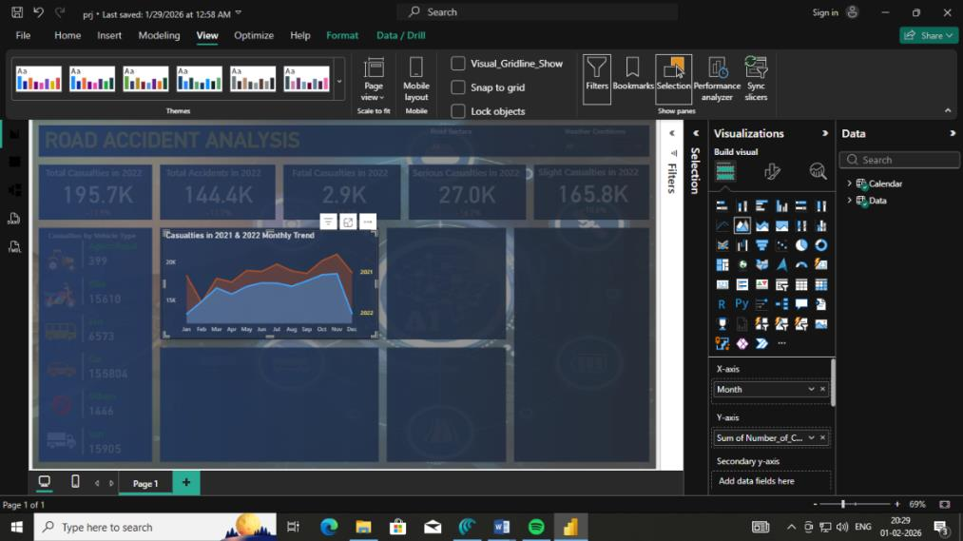
Monthly casualty trend comparing 2021 and 2022.
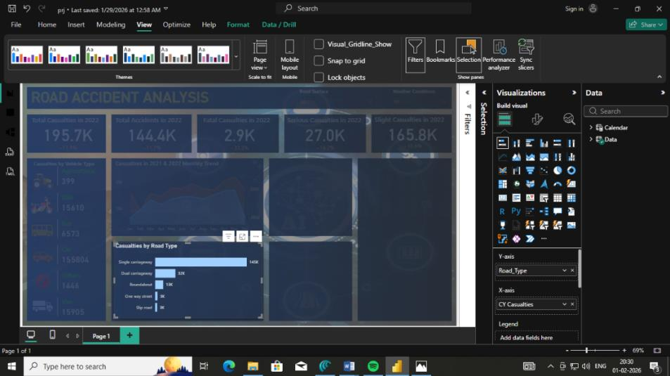
Casualties by Road Type, highlighting single carriageways as the highest-risk category.
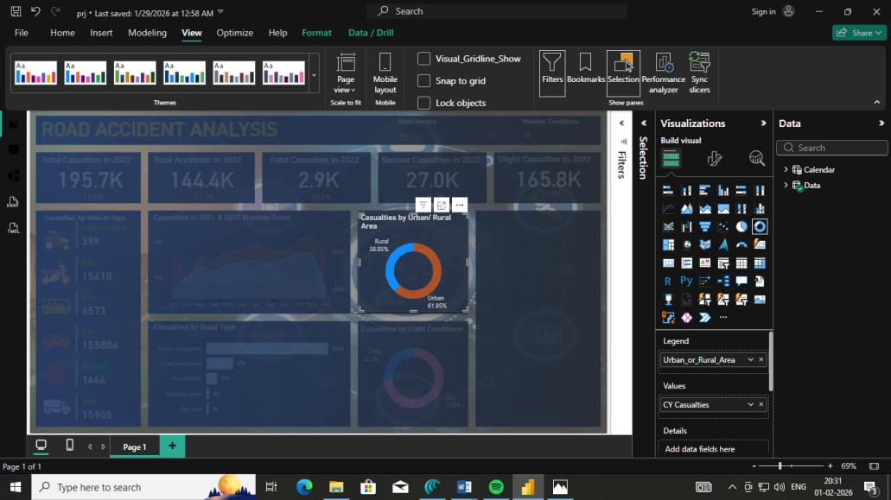
Urban vs Rural casualty distribution.
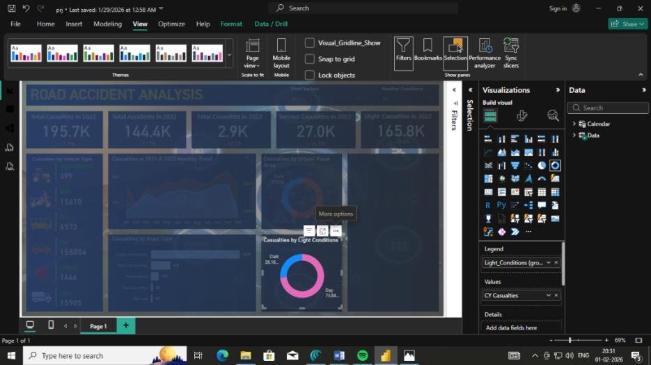
Casualties segmented by light condition (day vs night).
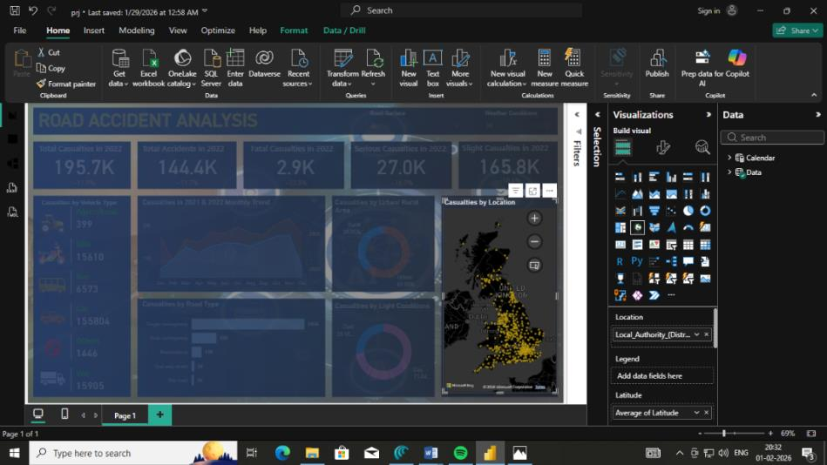
Geographic distribution of casualties by location.

Executive Challenge
If I were presenting this analysis to senior transport authorities, my three highest-priority recommendations would be:

1. Prioritise Single-Carriageway Safety Improvements (Highest Priority)
Single carriageways account for roughly 145,000 casualties — far more than any other road type. Targeted measures such as median barriers, speed enforcement, and junction redesign on these roads would likely produce the largest reduction in casualties of any single intervention.

2. Strengthen Urban Daylight Safety Measures
With 61.9% of casualties occurring in urban areas and 73.8% during daylight hours, the data points to high-traffic, high-exposure conditions as the dominant risk driver rather than poor visibility. Traffic-calming measures, pedestrian crossing improvements, and stricter enforcement during peak daytime hours in cities would directly target where the bulk of casualties occur.

3. Sustain and Scale the Programmes Behind the 2022 Improvement
Total casualties fell by 11.9% in 2022 compared to the previous year, suggesting that existing safety initiatives and enforcement are having a measurable effect. Identifying which specific programmes ran during this period and scaling the most effective ones, while using the monthly trend data to anticipate seasonal spikes, would help extend this downward trend into future years.

Conclusion
This Road Accident Analysis dashboard converts a large, granular dataset into a clear, interactive narrative about where and when road risk is concentrated. The 11.9% year-over-year decline in casualties is an encouraging signal that current safety measures are working, but the continued scale of casualties on single carriageways and within urban daylight conditions shows that targeted intervention still has significant room to deliver further gains. By combining KPI tracking, trend analysis, categorical breakdowns, and geographic mapping in a single Power BI report, stakeholders are equipped with the evidence needed to prioritise infrastructure investment, enforcement, and awareness campaigns where they will have the greatest impact on saving lives.

